Archery is a sport for all. If you are interested in finding out more, our beginners courses are the ideal introduction to the sport.
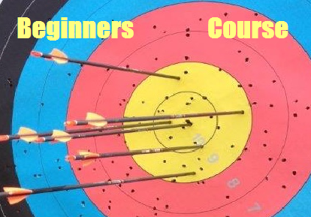
The course runs from:
Friday 22nd June 2018 (6:30pm to 8:30pm) and concludes on
Saturday 23rd June 2018 (1pm to 5pm)
All equipment is provided.
Seniors(18 upwards) £50
Juniors(9-17 years) £30
Places are limited and in demand, so please book early.
To book your place or ask a question please email
enquiries@clophillac.co.uk
Further information:
www.clophillac.co.uk

